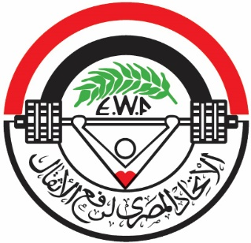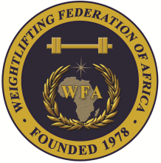

**African Junior and Youth Weightlifting Championships**

**October 26-31, 2023/Cairo, Egypt**

**TEAM ACCOMMODATION FORM**

**Country:**

|  |  |  |
| --- | --- | --- |
| Date | Single Room | Double Room |
| Oct. 24, 2023 |  |  |
| Oct. 25, 2023 |  |  |
| Oct. 26, 2023 |  |  |
| Oct. 27, 2023 |  |  |
| Oct. 28, 2023 |  |  |
| Oct. 29, 2023 |  |  |
| Oct. 30, 2023 |  |  |
| Oct. 31, 2023 |  |  |

President or General Secretary

Name:_____________________________ Date:_____________ Signature: _____________

Should be sent to LOC and WFA no later than September 26, 2023

**Organising Federation: Continental Federation:**

E-mail: weightlifting_egy@yahoo.com E-mail: [manareddin.eshelli@wfa.com.ly](mailto:manareddin.eshelli@wfa.com.ly)