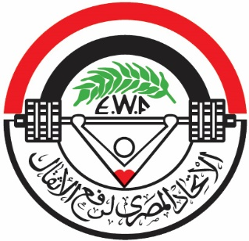
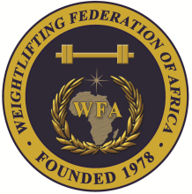
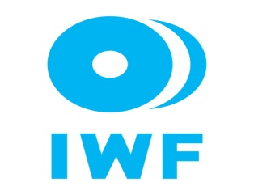

African Junior and Youth Weightlifting Championships
October 26-31, 2023/Cairo, Egypt

MEDIA FORM

Last Name………………………………………… Name…………………………………..
Nationality………………………………………… Employee………………………………
Address……………………………………………. Province ………………………………..
Identification/Passport No. ..…………………….. City……………………………...............

□ Journalist □ News Agency □ Daily newspape
□ Sport Magazine □ Photographer □ Radio Reporter
□ TV Reporter □ Other: ………………………………………

What communication type you will use?
□ Telephone □ Fax □ E-mail □ Other: ………………………….
Departure
Date/Time: ____________________

Flight Number: ___________________

Signature: _______________________
Arrival
Date/Time:_______________________

Flight Number: ___________________

Signature: _______________________

There are 2 options for Media representatives:

Pay Participation Fee with arrangement of accommodation at the official hotel with full board i.e. meals, airport transfers and media credentials from the Local Organizing Committee (LOC).

Single Room: USD $140 per person, per day.

Double Room: USD $110 per person, per day.

Pay an Entry Fee only ($ 100/person) without any arrangement from the LOC advance approval required.

President or General Secretary

Name:_____________________________ Date:_____________ Signature: _____________

Should be sent to LOC and WFA no later than September 26th, 2023

Organising Federation: Continental Federation:
E-mail: weightlifting_egy@yahoo.com E-mail: manareddin.eshelli@wfa.com.ly

