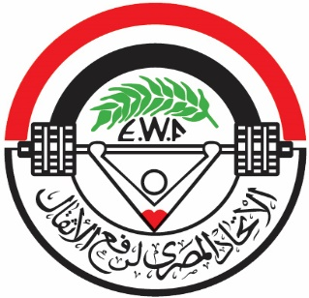

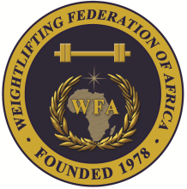

African Junior and Youth Weightlifting Championships
October 26-31, 2023/Cairo, Egypt

FINAL WOMEN YOUTH ENTRY FORM
Country:

No. | Athlete's name |  | Date of birth |  |  | Bodyweight Category | Entry Total
 | Family | Given | DD | MM | YYYY
1
2
3
4
5
6
7
8
9
10
11R
12R

No. | Official’s name |  | Date of birth |  |  | Function
 | Family | Given | DD | MM | YYYY
1
2
3
4
5
President or General Secretary

Name:_____________________________ Date:_____________ Signature: _____________

Should be sent to LOC and WFA no later than September 26, 2023

Organising Federation: Continental Federation:
E-mail: weightlifting_egy@yahoo.com E-mail: manareddin.eshelli@wfa.com.ly

