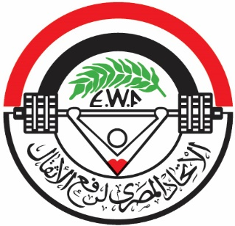

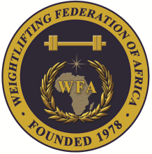

African Junior and Youth Weightlifting Championships
October 26-31, 2023/Cairo, Egypt

TEAM ACCOMMODATION FORM

Country:

Date | Single Room | Double Room
Oct. 24, 2023
Oct. 25, 2023
Oct. 26, 2023
Oct. 27, 2023
Oct. 28, 2023
Oct. 29, 2023
Oct. 30, 2023
Oct. 31, 2023

President or General Secretary

Name:_____________________________ Date:_____________ Signature: _____________

Should be sent to LOC and WFA no later than September 26, 2023

Organising Federation: Continental Federation:
E-mail: weightlifting_egy@yahoo.com E-mail: manareddin.eshelli@wfa.com.ly

