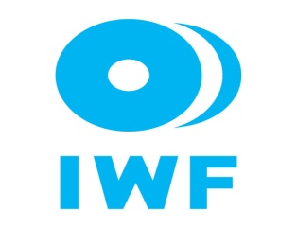

**2024 African Junior and Youth Weightlifting Championships**

**November 16-23, 2024/Nairobi, Kenya**

**TEAM ACCOMMODATION FORM**

**Country:**

|  |  |  |
| --- | --- | --- |
| Date | Single Room | Double Room |
| Nov. 15, 2024 |  |  |
| Nov. 16, 2024 |  |  |
| Nov. 17, 2024 |  |  |
| Nov. 18, 2024 |  |  |
| Nov. 19, 2024 |  |  |
| Nov. 20, 2024 |  |  |
| Nov. 21, 2024 |  |  |
| Nov. 22, 2024 |  |  |
| Nov. 23, 2024 |  |  |

President or General Secretary

Name:_____________________________ Date:_____________ Signature: _____________

Should be sent to LOC (KEN) and WFA no later than October 18, 2024

**Organising Federation: Continental Federation:**

E-mail: weightliftingkenya@yahoo.com E-mail: [manareddin.eshelli@wfa.com.ly](mailto:manareddin.eshelli@wfa.com.ly)