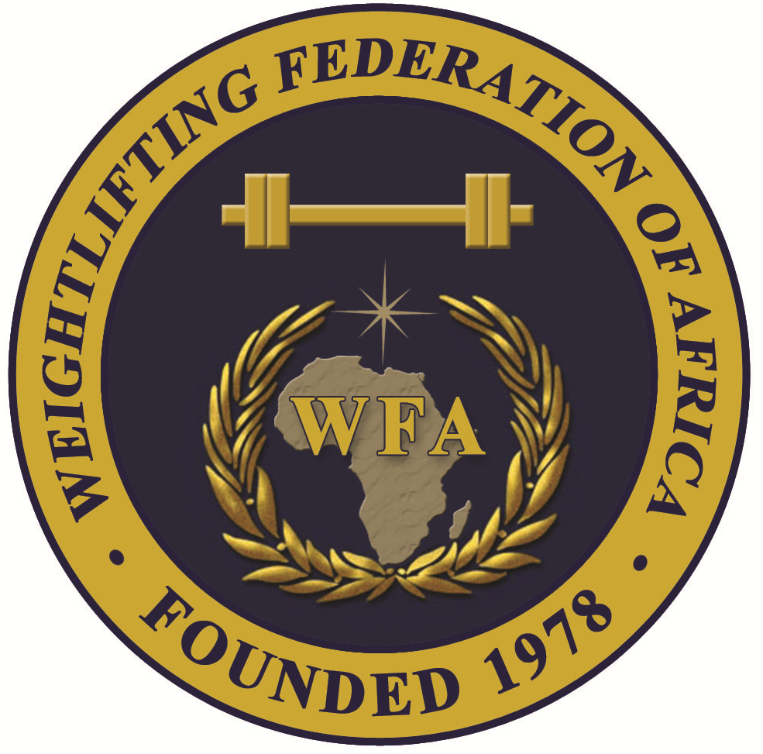
WEIGHTLIFTING FEDERATION OF AFRICA
Technical Officials Nomination Form for 2024 African Junior and Youth Weightlifting Championships

No. | Gender  M/F | Family Name(s) | Given Name(s) | Date of birth  (dd.mm.yyyy) | TO Card Number | TO Category | Work experience in 2021-2024  at IWF & WFA Events  Year / Event
1
2
3
4
Return to WFA by e-mail : manareddin.eshelli@wfa.com.ly Deadline: 31/08/2024
Nominate maximum 2 W / 2 M Please use these abbreviations:
Country code: Date: OG Olympic Games CC Continental Championships
YOG Youth Olympic Games CG Continental Games
WC IWF World Championships YCG Youth Continental Games
JWC Junior World Championships RC Regional Championships
Signature: Stamp: YWC Youth World Championships U Universiade
CWG Commonwealth Games WUC World University Championships

Please use computer to complete this form

