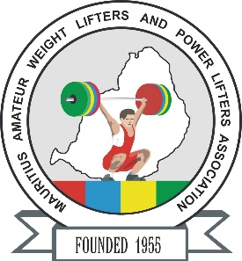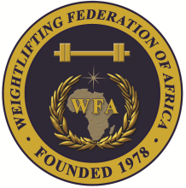

**African Senior (35th Men & 24th Women) Weightlifting Championships**

**20-28/04/2025 /Moka, Mauritius**

**TEAM ACCOMMODATION FORM**

**Country:**

|  |  |  |  |
| --- | --- | --- | --- |
| Date | Single rooms | Twin rooms | Triple rooms |
| April 19, 2025 |  |  |  |
| April 20, 2025 |  |  |  |
| April 21, 2025 |  |  |  |
| April 22, 2025 |  |  |  |
| April 23, 2025 |  |  |  |
| April 24, 2025 |  |  |  |
| April 25, 2025 |  |  |  |
| April 26, 2025 |  |  |  |
| April 27, 2025 |  |  |  |
| April 28, 2025 |  |  |  |

**President or General Secretary**

**Name:** **Date:** **Signature:**

Should be sent to OC and WFA respectively no later than March 23rd, 2025

**Organising Federation (MRI): Continental Federation (WFA):**

**E-mail:** mauritius.weightlifting@hotmail.com **E-mail:** [manareddin.eshelli@wfa.com.ly](mailto:manareddin.eshelli@wfa.com.ly)