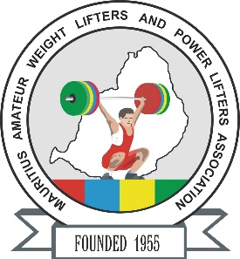

**African Senior (35th Men & 24th Women) Weightlifting Championships**

**20-28/04/2025 /Moka, Mauritius**

**FLIGHT SCHEDULE FORM**

**Country:**

|  |  |  |  |  |  |  |  |
| --- | --- | --- | --- | --- | --- | --- | --- |
| **No.** | **Name** | **Position** | **Passport No.** | **Arrival Details**  **Date, Time** | **Airline flight No.** | **Departure Details**  **Date Time** | **Airline flight No.** |
| **1** |  |  |  |  |  |  |  |
| **2** |  |  |  |  |  |  |  |
| **3** |  |  |  |  |  |  |  |
| **4** |  |  |  |  |  |  |  |
| **5** |  |  |  |  |  |  |  |
| **6** |  |  |  |  |  |  |  |
| **7** |  |  |  |  |  |  |  |
| **8** |  |  |  |  |  |  |  |
| **9** |  |  |  |  |  |  |  |
| **10** |  |  |  |  |  |  |  |
| **11** |  |  |  |  |  |  |  |
| **12** |  |  |  |  |  |  |  |
| **13** |  |  |  |  |  |  |  |
| **14** |  |  |  |  |  |  |  |
| **15** |  |  |  |  |  |  |  |
| **16** |  |  |  |  |  |  |  |
| **17** |  |  |  |  |  |  |  |
| **18** |  |  |  |  |  |  |  |

**President or General Secretary**

**Name:** **Date:** **Signature:**

Should be sent to OC and WFA respectively no later than March 23rd, 2025

**Organising Federation (MRI): Continental Federation (WFA):**

**E-mail:** mauritius.weightlifting@hotmail.com **E-mail:** [manareddin.eshelli@wfa.com.ly](mailto:manareddin.eshelli@wfa.com.ly)